PIZZA SALES SQL QUERIES

1. **KPI’s:-**

**1.Total Revenue :**

SELECT **SUM**(total_price) AS total_revenue FROM pizza_sales_dup;

**OUTPUT:-**

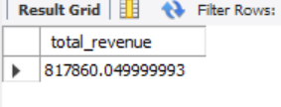

1. **Average Order Value :**

SELECT **SUM**(total_price)/**COUNT**( DISTINCT order_id ) AS avg_order_value FROM pizza_sales_dup;

**OUTPUT:-**

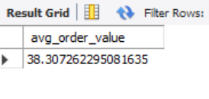

1. **Total Pizzas Sold :**

SELECT **SUM**(quantity) AS Total_Pizza_Sold FROM pizza_sales_dup**;**

**OUTPUT:-**

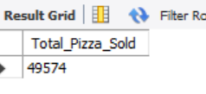

1. **Total Orders:**

SELECT COUNT(DISTINCT order_id) AS Total_Orders FROM pizza_sales_dup;

**OUTPUT:-**

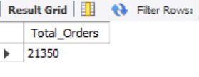

1. **Average Pizzas Per Order:**

SELECT CAST(SUM(quantity)/ COUNT(DISTINCT order_id) AS DECIMAL(10,2)) AS avg_pizzas_per_order FROM pizza_sales_dup;

**OUTPUT:-**

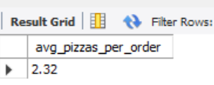

**B.CHARTS REQUIREMENT:-**

1. **Daily Trend for Total Orders:**

SELECT DAYNAME(order_date) AS order_day ,COUNT(DISTINCT order_id) AS total_order_per_week FROM pizza_sales_dup GROUP BY DAYNAME(order_date);

**OUTPUT:-**

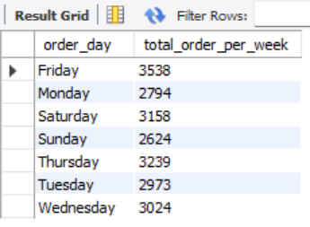

1. **Monthly Trend for Total Orders:**

SELECT **MONTHNAME**(order_date) AS order_month , **COUNT**(DISTINCT order_id) AS total_order_per_month FROM pizza_sales_dup GROUP BY **MONTHNAME**(order_date);

**OUTPUT:-**

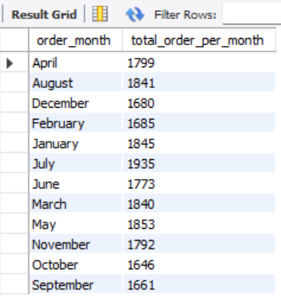

1. **% of Sales by Pizza Category:**

SELECT pizza_category,SUM(total_price)*100 /

(SELECT SUM(total_price) FROM pizza_sales_dup ) AS percentage_sale_by

category FROM pizza_sales_dup GROUP BY pizza_category;

**OUTPUT:-**

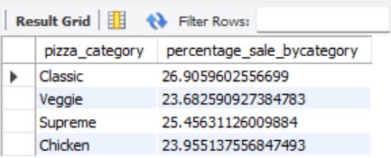

1. **Percentage of Sales by Pizza SIZE:**

SELECT pizza_size,SUM(total_price)*100 /(SELECT SUM(total_price) FROM pizza_sales_dup ) AS percentage_sale_bysize FROM pizza_sales_dup

GROUP BY pizza_size;

**OUTPUT:-**

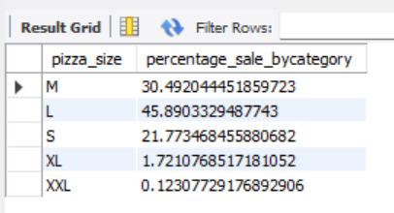

1. **Total Pizzas Sold by Pizza Category:**

SELECT pizza_category ,SUM(quantity) AS total_pizza_sold

FROM pizza_sales_dup

GROUP BY pizza_category;

**OUTPUT:-**

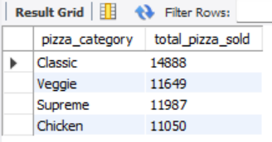

1. **Top 5 Best Sellers by Revenue:-**

SELECT pizza_name,SUM(total_price) AS total_revenue

FROM pizza_sales_dup

GROUP BY pizza_name

ORDER BY total_revenue DESC

LIMIT 5;

**OUTPUT:-**

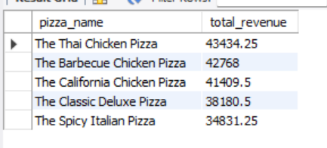

1. **Top 5 Best Sellers by Total Quantity :-**

SELECT pizza_name,SUM(quantity) AS total_quantity

FROM pizza_sales_dup

GROUP BY pizza_name

ORDER BY total_quantity DESC

LIMIT 5;

**OUTPUT:-**

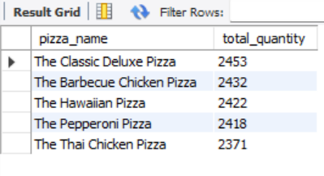

1. **Top 5 Best Sellers by Total Orders:-**

SELECT pizza_name,COUNT(DISTINCT order_id) AS total_order

FROM pizza_sales_dup

GROUP BY pizza_name

ORDER BY total_order DESC

LIMIT 5;

**OUTPUT:-**

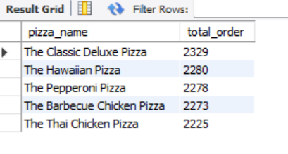

1. **Bottom 5 Best Sellers by Revenue:-**

SELECT pizza_name,SUM(total_price) AS total_revenue

FROM pizza_sales_dup

GROUP BY pizza_name

ORDER BY total_revenue ASC

LIMIT 5;

**OUTPUT:-**

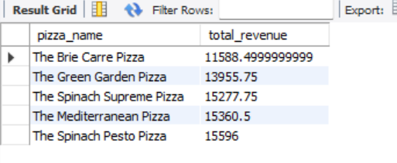

**10.Bottom 5 Best Sellers by Total Quantity:-**

SELECT pizza_name,SUM(quantity) AS total_quantity

FROM pizza_sales_dup

GROUP BY pizza_name

ORDER BY total_quantity ASC

LIMIT 5;

**OUTPUT:-**

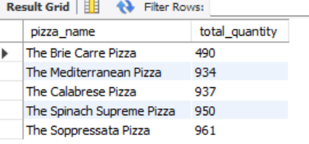

**11.Bottom 5 Best Sellers by Total Orders:-**

SELECT pizza_name,COUNT(DISTINCT order_id) AS total_order

FROM pizza_sales_dup

GROUP BY pizza_name

ORDER BY total_order ASC

LIMIT 5;

**OUTPUT:-**

